VIEWS : COMPOSITE VIEW/ JOIN VIEW, INLINE VIEW, FORCE VIEW

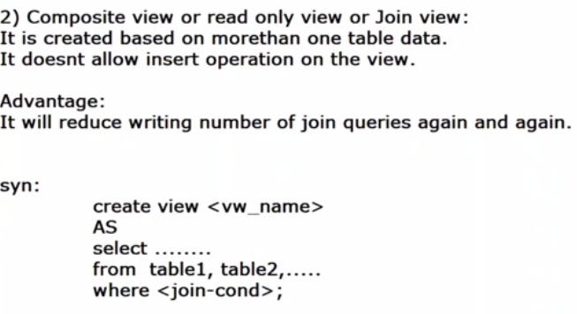

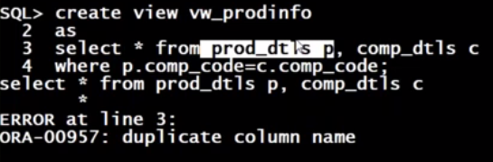

IF WE DON’T USE JOINS, WE GET ERROR IF WE HAVE DUPLICATE COLUMN NAMES.

NATURAL JOIN DISPLAYS COMMON COLUMN ONLY ONCE.

IN NATURAL JOIN WE SHOULD NOT SPECIFY ALIAS NAMES.

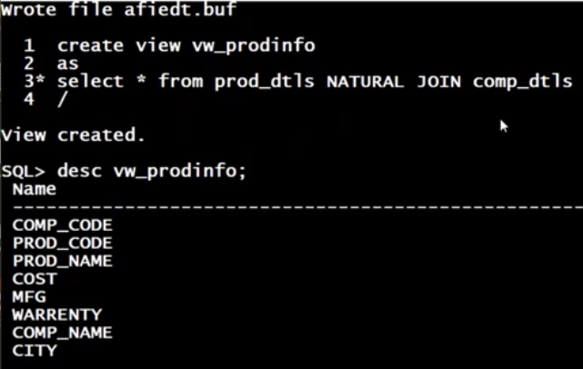

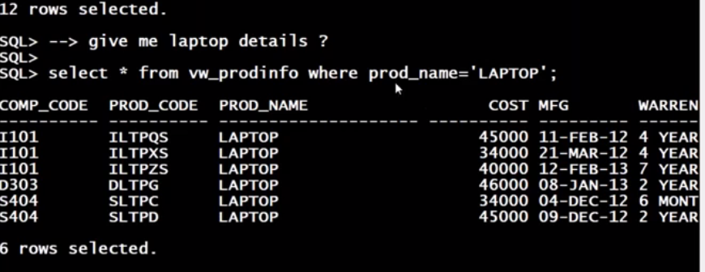

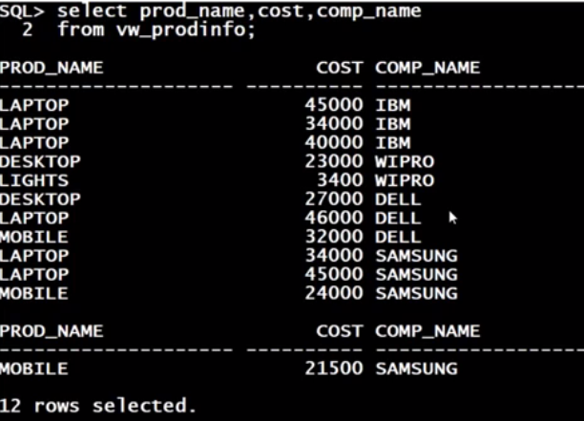

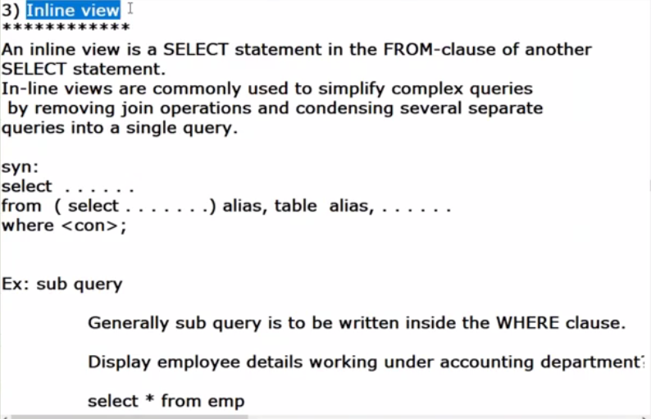

INLINE VIEW : THE SELECT QUERY USED AT FROM KEYWORD IN THE TOTAL QUERY IS CALLED INLINE VIEW.

: THE SELECT QUERY USED AT WHERE CLAUSE KEYWORD IN THE TOTAL QUERY IS CALLED SUB QUERY.

WE CAN BREAK COMPLICATED JOINS INTO SIMPLE THINGS.

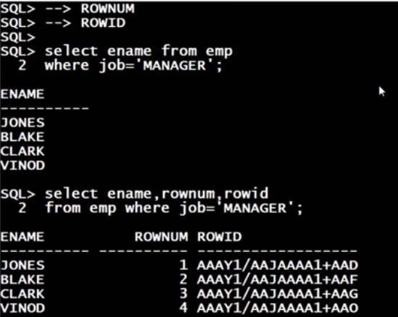

ROWID : ADDRESS OF EACH RECORD.

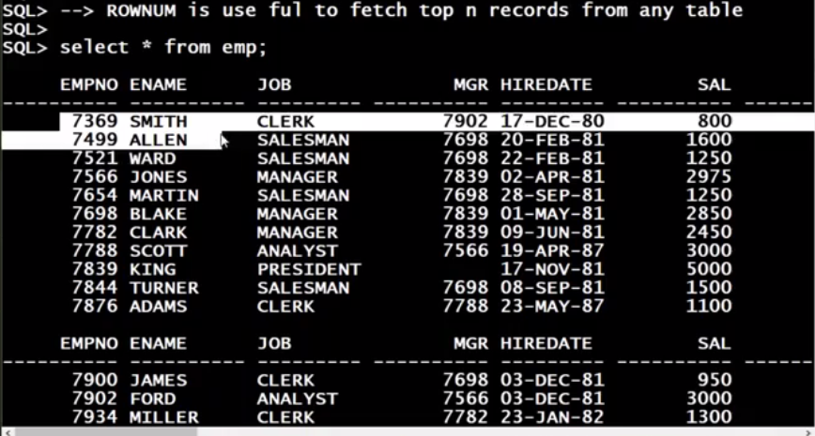

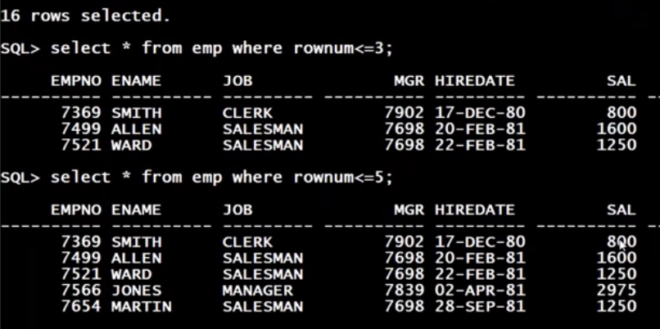

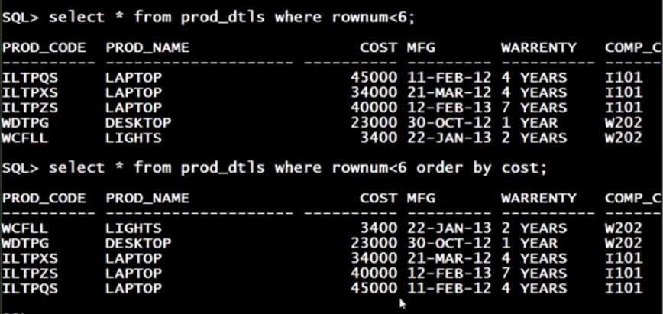

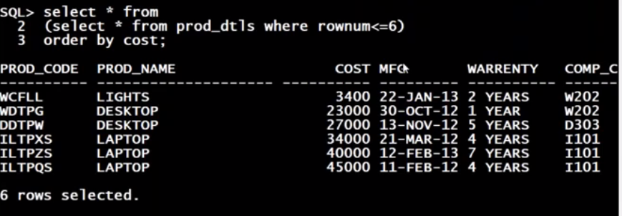

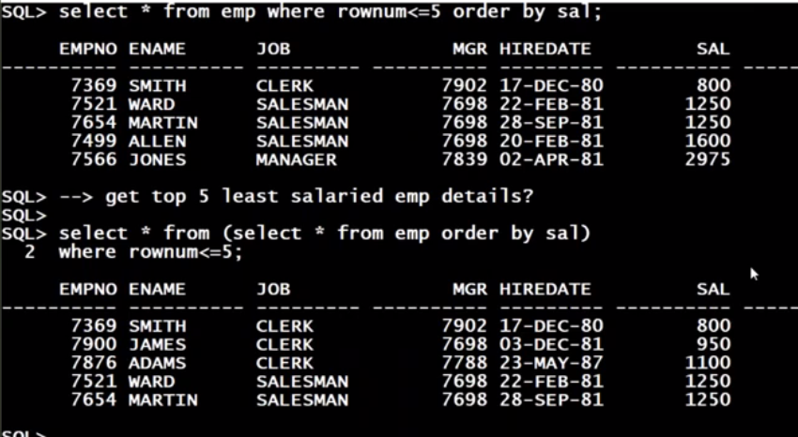

FIRST QUERY GIVES WRONG RESULT BUT 2ND QUERY(INLINE) GIVES RIGHT ANS.

